EdgeX Security WG Meeting 08/04/2020

Attendees:

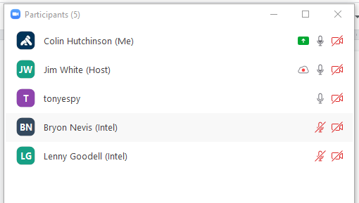
Agenda
- Action Items from last meeting
  - Action item: after the ssh tunneling guide lands in example repo double check external-device-security-examples is deleted (Colin)
  - Action item: pressure folks to review https://github.com/edgexfoundry/edgex-docs/issues/132
  - Action item: asynchronous determine delta between tribal knowledge vs what’s documented
    - Knowledge share session check if Tingyu can attend / participate
    - Investigate Kong w and without a datastore in EdgeX target to Ireland (Colin/Tony). Start a wiki page migrate the conclusion to an ADR

Colin tryout the JWT setup with EdgeX
    - Review project dashboard: https://github.com/orgs/edgexfoundry/projects/28
    - Options:
      - hbagdi/go-kong could replace EdgeX <=> Kong boilerplate
      - db-less declarative kong via yaml
      - hbagdi/deck kong via yaml with a datastore
  - Action item: Colin needs developer-scripts and edgex-docs (Jim White)
  - Action item: Jim Wang to merge his PR to the example repository ( in a /security/remote_devices folder but allow discussion during PR )

Notes

- Action Item: Bump vulnerable dependencies in https://github.com/edgexfoundry/device-bacnet-c (gnutls, musl) Jim White
- Action Item: aim for next security working group meeting to resolve and settle https://github.com/edgexfoundry/edgex-docs/pull/141. Post to slack channel that it’s last call ( Colin )
- Action Item: gently nudge folks to review https://github.com/edgexfoundry/edgex-go/pull/2574 ( Colin )

