EdgeX Security WG Meeting 08/26/2020

Attendees:

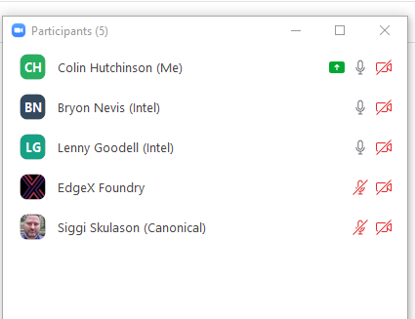
Agenda
- Action Items from last meeting
  - Action item: notify TSC that edgex-go/issues/1955 is at risk
  - Action item: edgex-go/issues/1955 should become a here to there plan wiki doc / google doc / possibly becomes an ADR
  - Action item: ack edgexfoundry/docker-edgex-mongo and edgexfoundry/docker-edgex-volume as won’t fix
  - Action item: ack edgexfoundry/consul:1.1.0 as not vulnerable
  - Action item: bump consul to 1.7.7
  - Action item: ack edgexfoundry/consul:1.2.0 jq as not vulnerable
  - Action Item: Jim White going to discuss https://github.com/edgexfoundry/go-mod-secrets/issues/53 with Lenny
- Review Snyk
- Anything at risk of not making Hanoi?
- Any stretch goals possibly going to make it into Hanoi?
- Review
  - QA code review
  - In Progress
  - New
  - Release backlog if necessary
- Open

Notes
- Action Item: James present a POC of what a CIS docker benchmark guide may look like
- Action Item: Document the vulnerabilities on our disclosure page. Include details that we haven’t evaluated if the vulnerability is exploitable, fixing is upgrading
- Action Item: TSC approval that major and minor upgrades can be made via PR’s
- Action Item: Adjust docker-compose / dockerfile to only pin major.minor

