EdgeX Security WG Meeting 09/23/2020

Attendees:

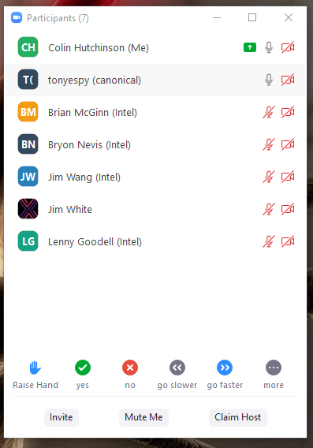
Agenda
- Action Items from last meeting
  - Action item: adjust proxy setup to use kong acl allow / deny (possibly Ireland scoped) and upgrade Kong to above 2.0 (Colin)
  - Action item: edgex-go/issues/1955 should become a here to there plan wiki doc / google doc / possibly becomes an ADR
    - Let’s document the hurdles (as a checklist) for what needs to adjust
  - Action item: ack edgexfoundry/docker-edgex-mongo and edgexfoundry/docker-edgex-volume as won’t fix
  - Action Item: James Gregg present a POC of what a CIS docker benchmark guide may look like
  - Action Item: Document the vulnerabilities on our disclosure page. Include details that we haven’t evaluated if the vulnerability is exploitable, fixing is upgrading (Colin)
  - Action Item: coordinate an application service release to verify we have fixes for the zeromq vulnerabilities (Colin create issue on edgex-go)
  - Action Item: snyk reports are for past images not for future images / work in progress. (ping devops if snyk can scan nexus not docker hub - Jim White)
  - Action Item: validate new builds get 4.3.3 of zeromq (Lenny)
  - Action Item: create a github issue to validate we’re not vulnerable to edgex-go:go.mod https://app.snyk.io/vuln/SNYK-GOLANG-GITHUBCOMDGRIJALVAJWTGO-596515
  - Action Item: will https://github.com/edgexfoundry/edgex-go/issues/2495 slip how critical is it? (Tony)
  - Action Item: https://github.com/edgexfoundry/edgex-docs/pull/220 needs approval / a read (Colin / Tony)
  - Action Item: confirm at TSC https://github.com/edgexfoundry/edgex-docs/issues/136 likely not making Hanoi
  - Action Item: https://github.com/edgexfoundry/edgex-go/issues/2537 (Colin)
- Review Snyk
- Anything at risk of not making Hanoi?
- Review
  - QA code review
  - In Progress
  - New
  - Release backlog if necessary
- Open

Notes
- Action Item: adjust snyc such that we’re only scanning 1.2.latest. Device and app services might be an exception -- tread carefully
- Action Item: https://github.com/edgexfoundry/edgex-docs/pull/140 review prior to end of October (Tony)
- Action Item: contact brett preston of linux foundation get on security-issues@lists.edgexfoundry.org distribution list (Colin)

