EdgeX Security WG Meeting
2/3/2020

Attendees:

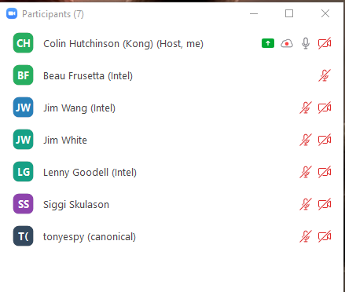
Standing Agenda
- Backlog progress sheet ( https://bit.ly/2UFJWGA )
- Review Security Provider for All Project Board ( https://github.com/orgs/edgexfoundry/projects/37 )
- Review Security Board ( https://github.com/orgs/edgexfoundry/projects/28 )
- Review Snyc ( https://app.snyk.io/org/edgex-jenkins/projects )
  - Filter With Issues & Active

Agenda

Notes

