EdgeX Security WG Meeting
3/3/2020

Attendees:

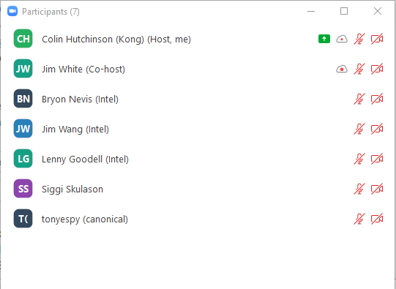

Standing Agenda
- Backlog progress sheet
- Review Security Provider for All Project Board
- Review Security Board
- Review CIS docker scan
- Review Snyc
  - Filter With Issues & Active

Agenda

Notes
- Bryon: Investigate why CIS benchmark tool thinks edgex-redis is running as root
- Lenny: create issues for the bootstrap scripts to run as non-root
  - Related: email thread and CIS scan
- Colin: Edgex-device-virtual should mount a volume and not have a R/W filesystem
- Colin: Find a way to ignore all vault warnings in the CIS scan
- Colin: Find a way to ignore the edgex-sys-mgmt-agent in the CIS scan
- Lenny: Create issue related to proxy-setup override
- Securing consul notes:
  - Phase 1: is backwards compatible and not a breaking change
  - Phase 2: is a non backwards compatible breaking change (if running in secure mode / feature flagged)
  - Phase 3: is not a backwards breaking change with phase 2
  - Lenny: If we feature flag phase 2 and it’s incomplete that’s OK no need to push the release date
- Re-evaluate at the end of April if we can meet / meet with a different release date or skip implementation of Securing Consul Phase 2
- Next security wg meeting: https://lists.edgexfoundry.org/g/EdgeX-TSC-Security/message/352#
- Colin: get the docker security scan ran again
- Colin: add a review of the security scan to the weekly security group meetings

