EdgeX Security WG Meeting
3/31/2020

Attendees:

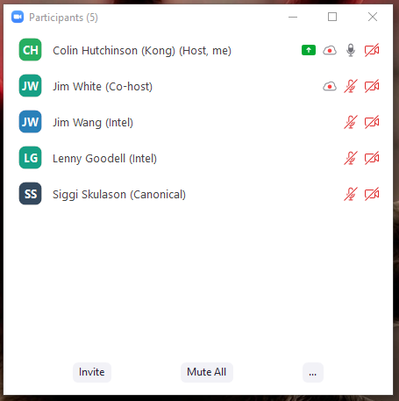
Standing Agenda
- Backlog progress sheet
- Review Security Provider for All Project Board
- Review Security Board
- Securing Consul Board
- Review CIS docker scan
- Review Snyc
  - Filter With Issues & Active

Agenda

Notes
- Action Item: Colin get devops to automate the CIS docker scan to happen weekly and make sure it happens at least once before next security wg meeting
- Action Item: Jim Wang create an issue that TAF will need to fetch a consul token

