EdgeX Security WG Meeting
4/14/2020

Attendees:

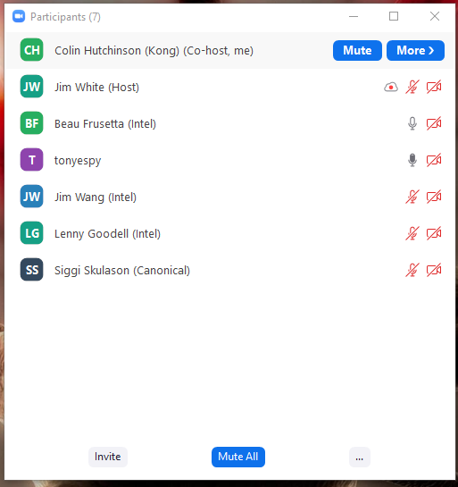
Standing Agenda
- Backlog progress sheet
- Review Security Provider for All Project Board (skip unless Lenny says not to)
- Review Security Board
- Securing Consul Board
- Review CIS docker scan (will skip unless something changes)
- Review Snyc (will skip unless something changes)
  - Filter With Issues & Active

Agenda

Notes
- Action Item: ADR to handle the addition of new services when in secure mode
- Action Item: discuss with architecture working group
  - Addition of new services when in secure mode has changed
- Action Item: need some non-intel reviews on the threat model adr https://github.com/edgexfoundry/edgex-docs/pull/259

