EdgeX Security WG Meeting
5/12/2020

Attendees:

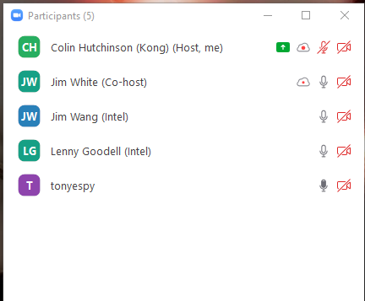

Standing Agenda
- Backlog progress sheet
- Review Security Provider for All Project Board (skip unless Lenny says not to)
- Review Security Board
- Securing Consul Board
- Review CIS docker scan (will skip unless something changes)
- Review Snyc (will skip unless something changes)
  - Filter With Issues & Active

Agenda
- remove the feature flag of "ENABLE_REGISTRY_ACL" (Jim Wang)
  - Remove the flag. If one wants this disabled it’s equivalent to unsecure mode

Notes

