QA/Test Working Group Meeting

Thursday, May 9th, 2019

Attendees:
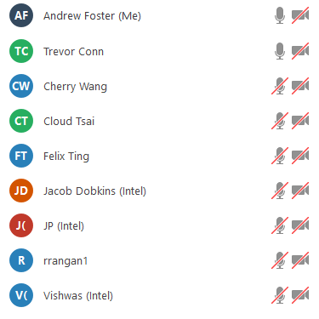

Jim White (Dell) – also attended the meeting
Agenda

Time | Item | Who
15 mins | Edinburgh release blackbox testing - test status and open issues review | Andy (IOTech), Cloud (IOTech)
15 mins | Seoul F2F – Meeting Outcomes | Andy (IOTech)
15 mins | New business | All

- Edinburgh Release Blackbox Testing Status
- Fixed issue #205, #208, #210, #212, #214, #217
- Merged PR #206, #207, #209, #211, #213, #215, #218, #219
- The following edgex-go issues cause some testcases failed on blackbox-testing
  - Transmission issue #1315, #1316, #1317
  - Scheduler issue #1308
  - Device service issue #87
  - Core command issue #1296
- 5 test failures on x86, (change 5 -> 56)
  - https://jenkins.edgexfoundry.org/view/blackbox-testing/job/blackbox-testing-centos7-blackbox-4c-2g-master/lastBuild/allure/
- 4 test failures on ARM (change 4 -> 58 )
  - https://jenkins.edgexfoundry.org/view/blackbox-testing/job/blackbox-testing-ubuntu18.04-docker-arm64-4c-2g-master/allure/#
- 5 new test failure on security job x86 (change 5 -> 54)
  - https://jenkins.edgexfoundry.org/view/blackbox-testing/job/blackbox-testing-security-centos7-blackbox-4c-2g-master/lastBuild/allure/
- Security job on ARM currently failing. See issue #185
- See https://github.com/edgexfoundry/blackbox-testing/issues

- Edinburgh QA/Test objectives Review
Requirement | Status | Notes
Visualization/dashboard of test results | Complete | Allure dashboarding for blackbox test deployed on EdgeX Jenkins Server
Capture of resource metrics to monitor performance | In Progress | Created Telegraf+InfuxDB+Grafana (TIG) stack to provides metrics (CPU, Memory) on EdgeX services.  LF have created and tested TIG stack setup.  QA/Test team have created a Jenkins Job for LF deployment and are currently testing on Sandbox. Subject to PRs #9 (edgexfoundry-holding ) and #338 (ci-management).
Performance/load testing | In Progress | Using JMeter to drive EdgeX APIs. TIG stack used to record API response times and metrics.  Tests running successfully on Jenkins Sandbox. Can also run multiple tests in parallel.  Tests have been moved from holding area to main repo.  Next Steps  Add additional performance tests – in progress
Automated blackbox testing for Security Services | In progress | Kong not officially supported on ARM 64 issue #185. Security WG have now built Kong for ARM64 and this is being added EdgeX repo.
Automated blackbox testing for new Go Scheduling Service | Complete | Being developed by the Core WG.
Swagger Documentation | Not Started | Has not been prioritized for Edinburgh

- Seoul Face-to-Face Outcomes
- Agreed Fuji roadmap

- New business
- Intel iTAF document - currently being reviewed
- Logging performance tests – initial PR #18 issued
- Startup times performance test – will require EdgeX microservices to be modified to return startup times in response to http://localhost:48096/api/v1/metrics.

