EdgeX Security WG Meeting 06/24/2020
Attendees:

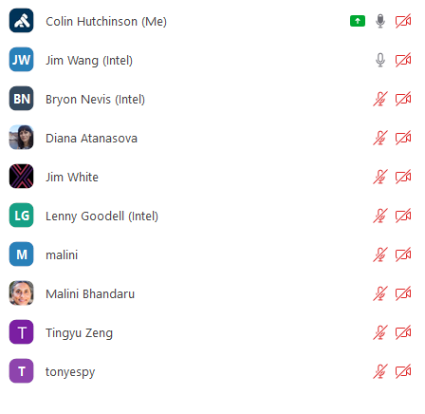
Agenda
- New Security Working Group Chair
  - Hi I’m Colin Hutchinson (Kong)
  - Still getting up to speed and getting necessary access etc
- Create an edgex holding repository for ssh tunneling reference implementation
  - Linux Foundation
  - EdgeX Foundry
  - Architecture meeting: where code samples go. HIstorically holding repository going forward somewhere else?
  - Can’t currently go into developer-scripts so it doesn’t accidentally become part of the release.
- Deprecated resources
  - Keep docker artifacts
  - Action item: document docker-compose’s as deprecated in the folders
  - Keep scanning the mongo repository
- Snyk meeting to transition (does next security WG work?)
  - Action item: Colin needs to know where the SIR process documentation is
- SIR Team
  - Lead: Colin
  - Action item: request volunteers at security WG / TSC
- Action item: Colin needs committer rights / board rights. Lisa has been contacted
- Action item: use the github board for issues only not PR’s as well and update automation
- Action item: review ADR PR’s
- Action item: how to archive a repository? Linux Foundation support ticket perhaps?

