Outreach Working Meeting
5/15/23
Attendance
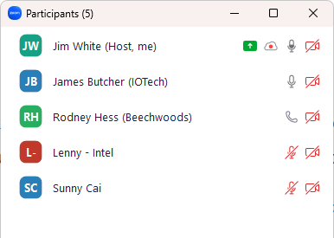
Gavin Hunter and Dan Brooks joined shortly after the meeting start.
Agenda
- LF Edge Website update (Sunny?)
  - Content submitted; Website to be updated (for all projects).
  - Image – not found; will higher res image work?
- Coding Competition updates?
  - 95 students signed up; forming teams
  - Coding starting this week; coding through July
- Eaton Use Case Document
  - Coming Soon (this week?)
- Social Media stats and study
  - Linked In
    - Good Engagement rate 2-3%
    - Good Click through rate 2-5%
    - Good Impressions #: 1K good, 5K great
  - Twitter
    - 0.5% good; 1% is great
    - Impressions in 100’s
    - Our engagement rate around 3% month over month
  - Take aways
    - LinkedIn better than Twitter for volume, impressions, quality of traffic
    - Dos
      - Release announcements
      - Highlight feature or value
      - Real use case/demonstration/reference
      - Offer or announce something of value/something new
      - Quick poll can provide good impression #s (not as high click through)
    - Don’ts
      - (Repetitive) Event announcements
      - Repeat content
      - Non-EdgeX product
      - Adopter replays (of the week)
      - Highlight the obvious (docs location, video location)
      - Tell me something I already know or repeat something over and over, tell me something outside of the project I don't care about

